Making Peace with Our Purpose

Rev. Dr. Michael Piazza
Sunday, September 30, 2018
Esther 4/Mark 9:38-50

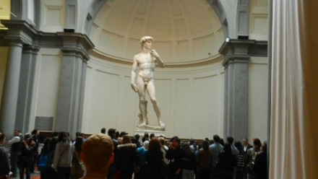
I am sure many of you have been to Florence and have seen Michelangelo’s David in person. Even though we all have seen thousands of images and copies over the years, nothing prepares you for the exquisite beauty of the real thing.

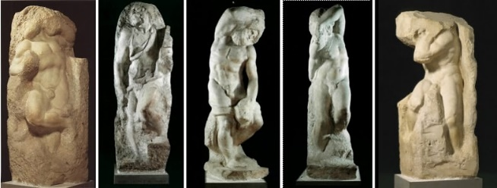
In the great hall leading up to David are several unfinished sculptures also by Michelangelo. He called these works the “Captives.” With a head, or a hand, or a partial body emerging from a block of marble, they, indeed, look like beings who are being held captive in stone. The Captives illustrate very clearly why sculptors often describe their job as setting free a work of art that is hidden inside the stone. They skillfully and patiently chip away all that hides the beauty of the image that only the artist can see within.

This also describes perfectly what the original Artist of the universe longs to do with each of us. If we will cooperate, God can use life to chip away whatever hides the beautiful art that hides inside each one of us.

Standing and staring at the masterpieces still captive in the stone can make your heart ache as you realize that these sculptures are much more accurate reflections of the state of our soul than the exquisite, graceful, unself-conscious beauty of David, only a few steps away.
There he stands for all the world to see, just as he was created to be, while you and I struggle, encased in stone, trying to realize and express our God-given purpose, our “WHY.”

We are a diverse lot in this church, but there is one thing that is absolutely true about each one of us:

Every day, we either are moving toward our purpose, or we are moving away from the purpose for which we were created.

When you leave this place today, in which direction will you be headed?

In his bestselling book “The Purpose Driven Life” Rick Warren reminds us that the average human life is lived for 25,550 days. If you are 40 or older, you may have used up at least half of your allotment. Wouldn’t it be tragic to get to the end of your days and discover that you have used them all wrong?

I have a $100 bill here. In case you are like me and have rarely seen one, that’s Benjamin Franklin’s picture on the front. I’m going to give it away. Who would like it? What if I step on it? Do you still want it? How about if I crumple it up? Now who would like it?

That’s right. Although it may be crumbled, and tattered, and dirty, it didn’t lose any of its value. Well, I want to remind you that if this is true about a green piece of paper, then how much truer is it about your life and about mine? We may be a bit tattered and worn. We may have gotten a little trampled and soiled. Still, in the hands of God, our life retains the same value we had on the day when we were born.

Your life, like this $100 bill, can be spent any way you choose, but you can spend it only once. So, choose well.

In the first lesson, we heard a favorite story from Jewish history of a heroine who rose up to save her people. She was wealthy, powerful, and well-positioned enough not to worry about how others were doing, but she did.

The story of Esther takes place during the oppression of the Persians. The Persians had conquered the Jews and kidnaped most of the artists, intellectuals, and skilled laborers and took them away into exile. During this time there lived a woman named Esther who was considered the most beautiful woman of her day. Even though she was a Jew, the King of Persia married her.

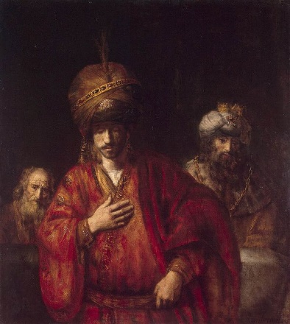
The villain in the story is named Haman, a Persian noble. Every time his name is mentioned when this story is told In Jewish homes or congregations, listeners boo, or hiss, or make noise with a gragger. Haman hated the Jews because a priest named Mordecai refused to bow down to him or to anyone other than God. So, Haman devised a plot to massacre all of the Jews. Mordecai, however, had a secret weapon: his cousin Esther.

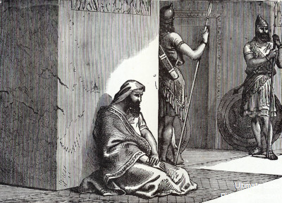
He could not get a message to her in the palace, though, so Mordecai dressed up in sackcloth and ashes and began wailing and moaning outside the king’s gates. Messengers soon came to tell Esther about him. She was so embarrassed that she sent him clothes to put on.

Mordecai wasn’t too concerned about his cousin’s embarrassment, but, instead, he sent word back, telling Esther of the plot and asking her to intervene. Esther’s first response was self-preservation. I’ve got mine; you get yours. (She might have made a good modern queen.)

Of course, she had a logical excuse. The king had not summoned her, so it was dangerous for her to take the initiative. She explained all of that to Mordecai, but listen to what he said to Esther:

Do not think that in the king’s palace you will escape any more than other Jews. For if you keep silent, relief and deliverance will rise from another quarter. Who knows? Perhaps you came into the kingdom for just such a time as this.

We, too, are fools if we think we can remain untouched by evil done to others. We are equally fools to think we have no responsibility for those who are struggling just because we may not be at the moment. It is foolish to think that, in our comfort, we have no obligation to seek the common good.

This was the same thing Jesus tried to teach us when he said, “The person who seeks to save their life will lose it, but the person willing to lose their life will find it.”
Susie turned five in July, so Susie and her mother made ice cream for her birthday. Susie’s mother wanted to invite the kids next door to share it, but Susie wanted to keep it all for herself. The problem was you can’t save homemade ice cream very well. Susie ate so much she made herself sick, and the rest was spoiled. The next year, Susie was a wise six-year-old, so she invited all the kids in the neighborhood. She had all the ice cream she wanted and gave the rest away. The wonderful thing was that the rest of the year, whenever the neighbors made ice cream, they invited her to share.

Our life is a lot like ice cream in July. You can’t save it, but you can make a lot of people happy by sharing it. In the end you are always the one most blessed.

One key to choosing faith over fear is to recognize we can’t save life for ourselves. Clinging to it, fearing for it, trying to hoard it will only spoil it. Giving it away to something or Someone bigger than you is the only way to give your life an eternal quality.

That is one of the reasons this place is so important. You can change the world from here, but it will require some serious investment. You will have to invest your soul in this place not as a consumer, but as a producer; not because of what you can get, but because of what you can give; not because you go to church, but because you ARE the Church.

Yes, we are going to ask you to invest your money, and I know it is tempting to wait until you have a permanent pastor. You, however, are not investing in me or in the one to come. During this interim, we are working to determine our WHY as a congregation.

Why have we as a church come into the Realm of God? Does God have an eternal purpose for us, or will we, like thousands of other churches, simply fade away?

Mordecai told Esther that she had to overcome her fears. She had to overcome the temptation to look out for herself. She had to overcome her own sense of entitlement. She had to risk her own position so others might have life.

If Jesus taught us anything it is this: Without sacrifice humankind will never be redeemed. Without sacrifice God’s children have no future, so we must overcome our sense of entitlement.

Jesus did not have to die to convince God to love you, but he was willing to make the ultimate sacrifice to convince you that you are loved by God.

Too many people believe that our “why” is found in making enough money, or marrying the right person, or finding the right job. We believe that will make us happy. Well, it won’t.

And who told you that you were meant to be happy, anyway? If you pursue happiness, you will never find it. Happiness is the byproduct of a well-lived life! Find the purpose for which you were created, and happiness will follow.

Jesus knew that including all in the family of God was his purpose, and, if it cost him his very life, so be it. After all, Jesus remembered what we are too prone to forget: We ALL are going to die. The question is whether we will live. If we do, will it matter?

Death holds no fear for a life that has been lived on purpose. Amen.

