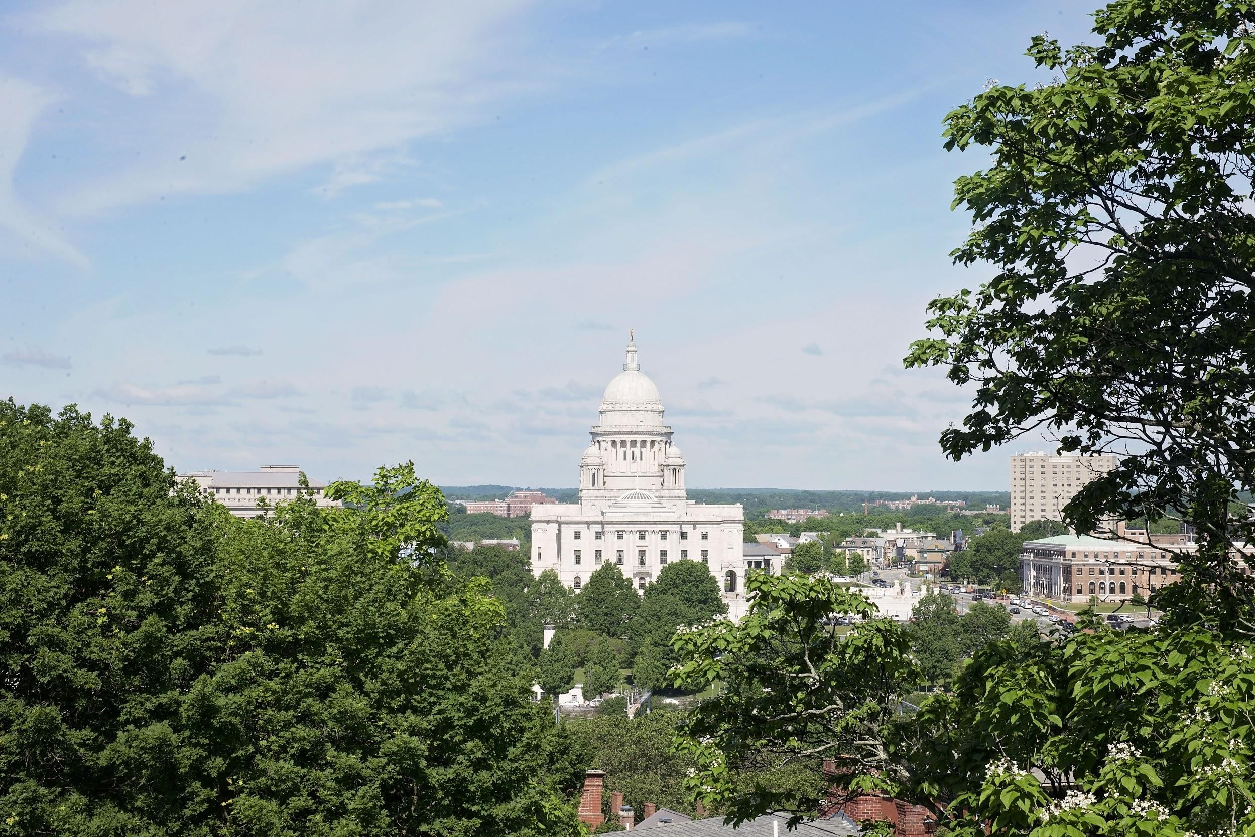

Providence
June 25th-June 30th

Floor Sleeping: $385 Per Person
- Bring Air Mattresses, Sheets, Towels, etc, for showering and sleeping
- Sleep in a local school or church
- Be near to serving location

Hotel Sleeping: $600 Per Person
- Sleep 4 people per room
- Have all linens provided
- 15-20 minute drive to serving location

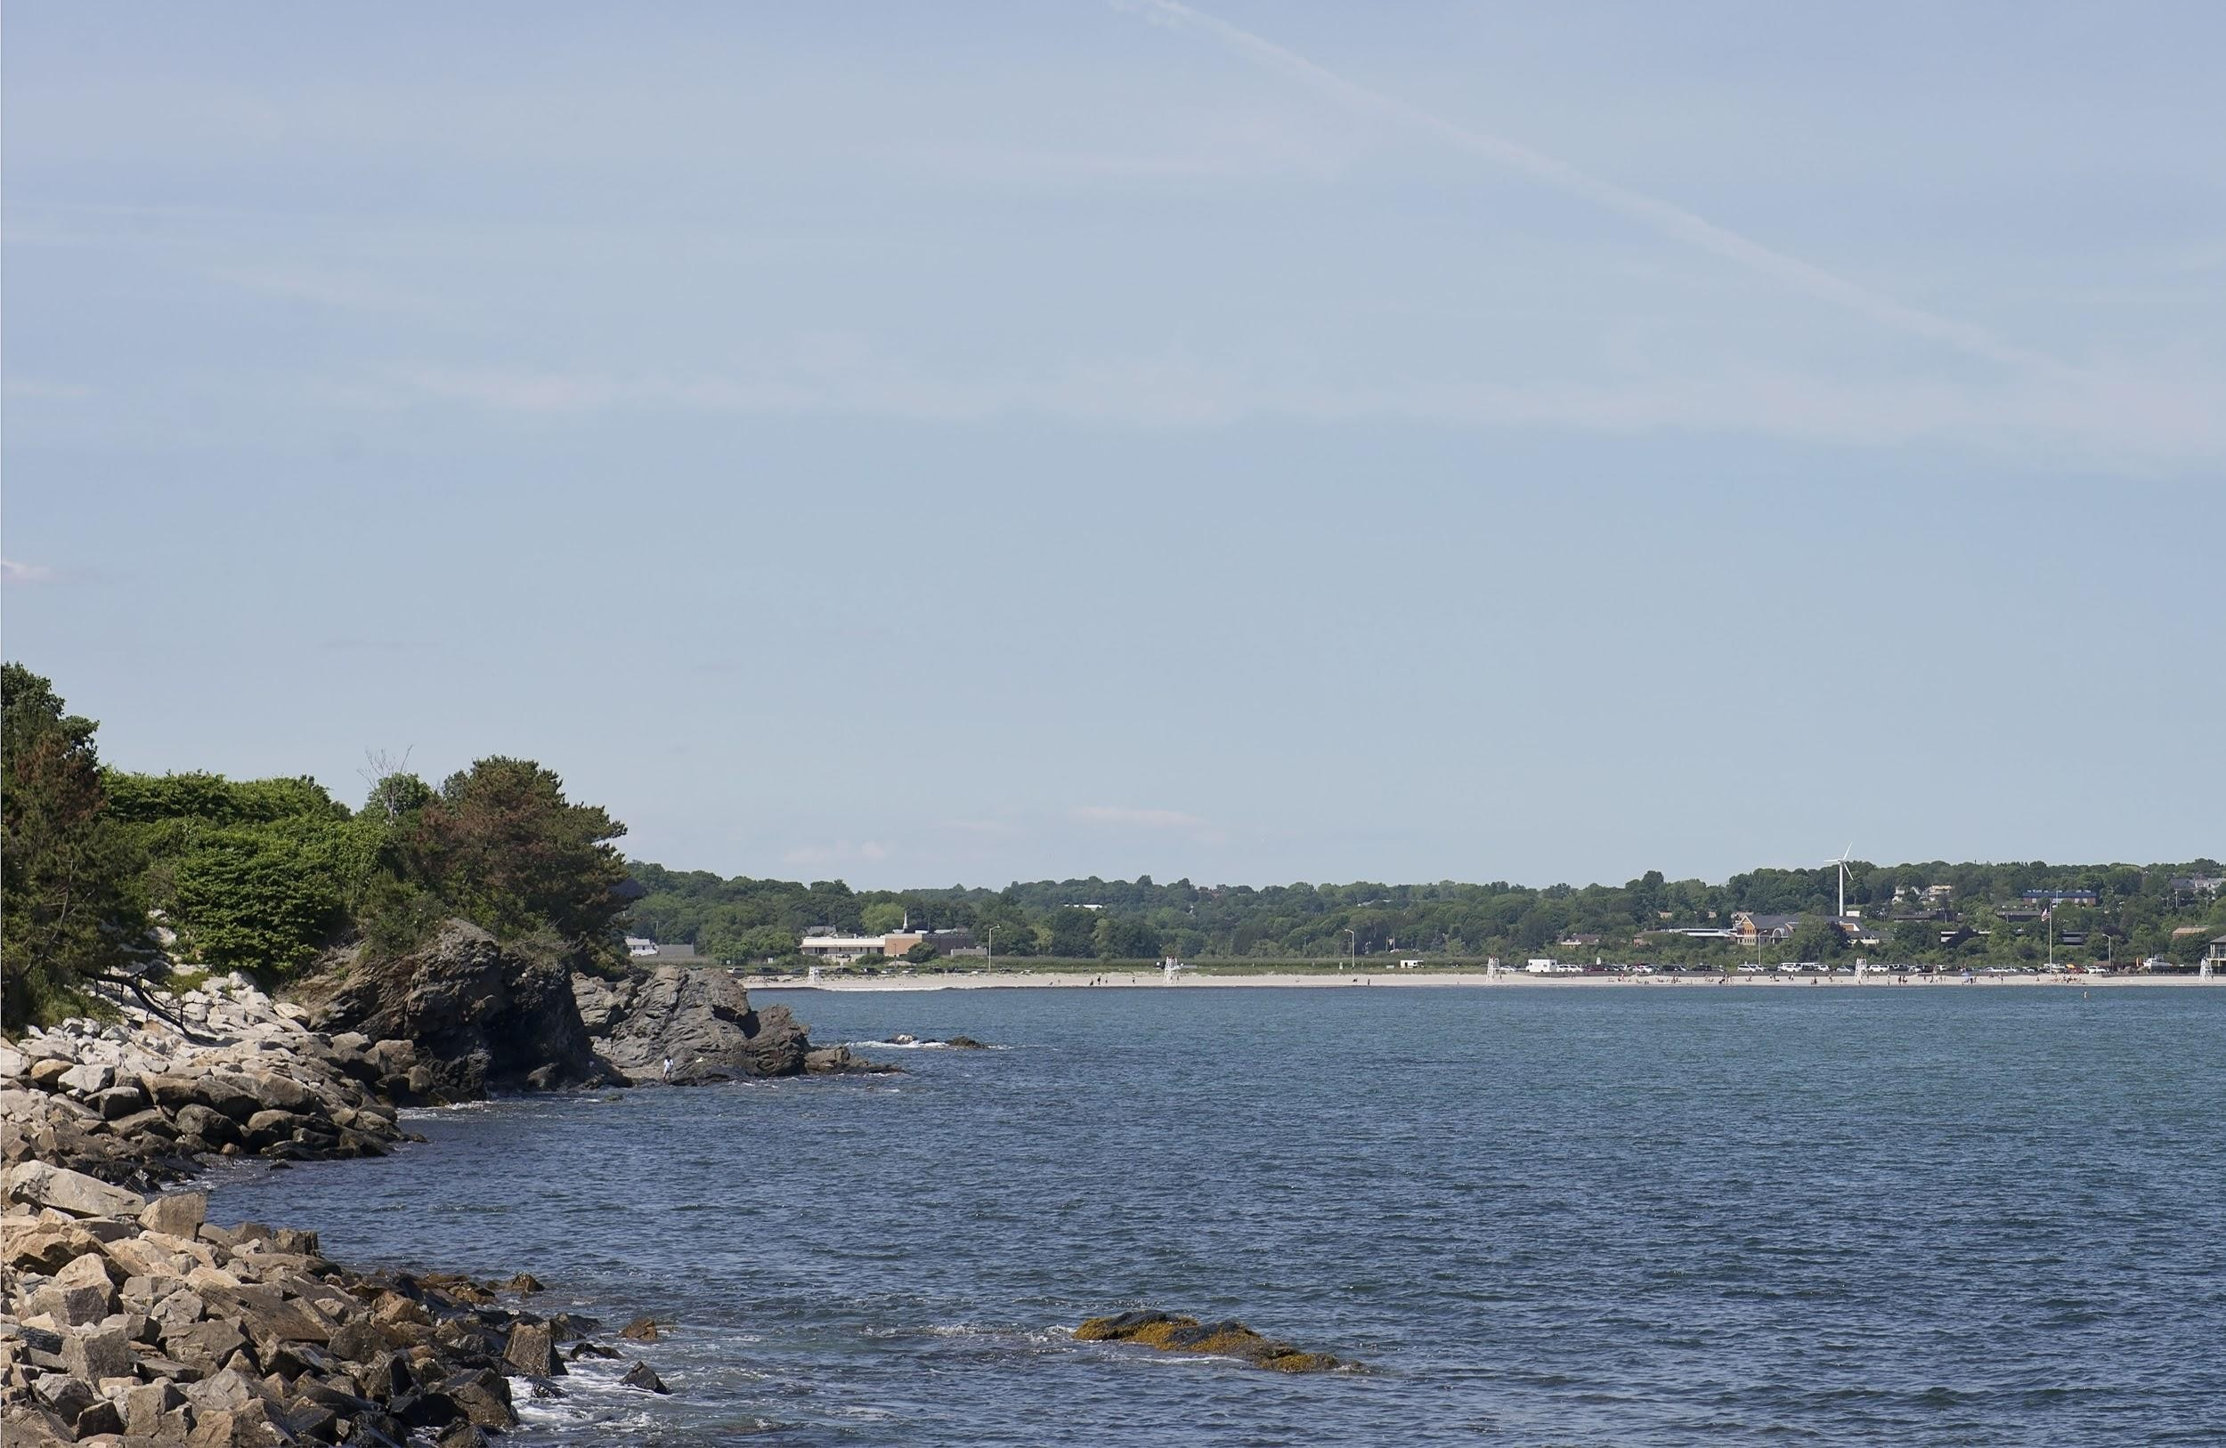
Work Projects

- Food Distribution Center Remodel
move food distribution trailer, clean out inside, put in refrigerators, paint new signs, paint outside of center, build shelving units, create check in area
$5000

- Gazebo & Basketball Court
lay cement, install basketball hoops, paint basketball court, build gazebo, lay path to area, beautification of area
$3000

Work Projects Cont.

- Rescue Mission Main Building Projects painting inside & outside, organizing, deep cleaning of kitchen, replacing flooring, staining cement basement floors, light lawn care
$750

- House Repairs for Men’s & Women’s Dorms. painting inside, lawn care, light cleaning
$400

Other Ministry Opportunities
Food Distribution
- Packaging and handing out food to the community.

Thrift Store
- Setting out items from the Mission for a free store for the community. It will be set up in the parking lot of the Mission.

Newport

Saling Beach Seafood Shopping
Boston

Freedom Trail Shopping Aquarium Seafood

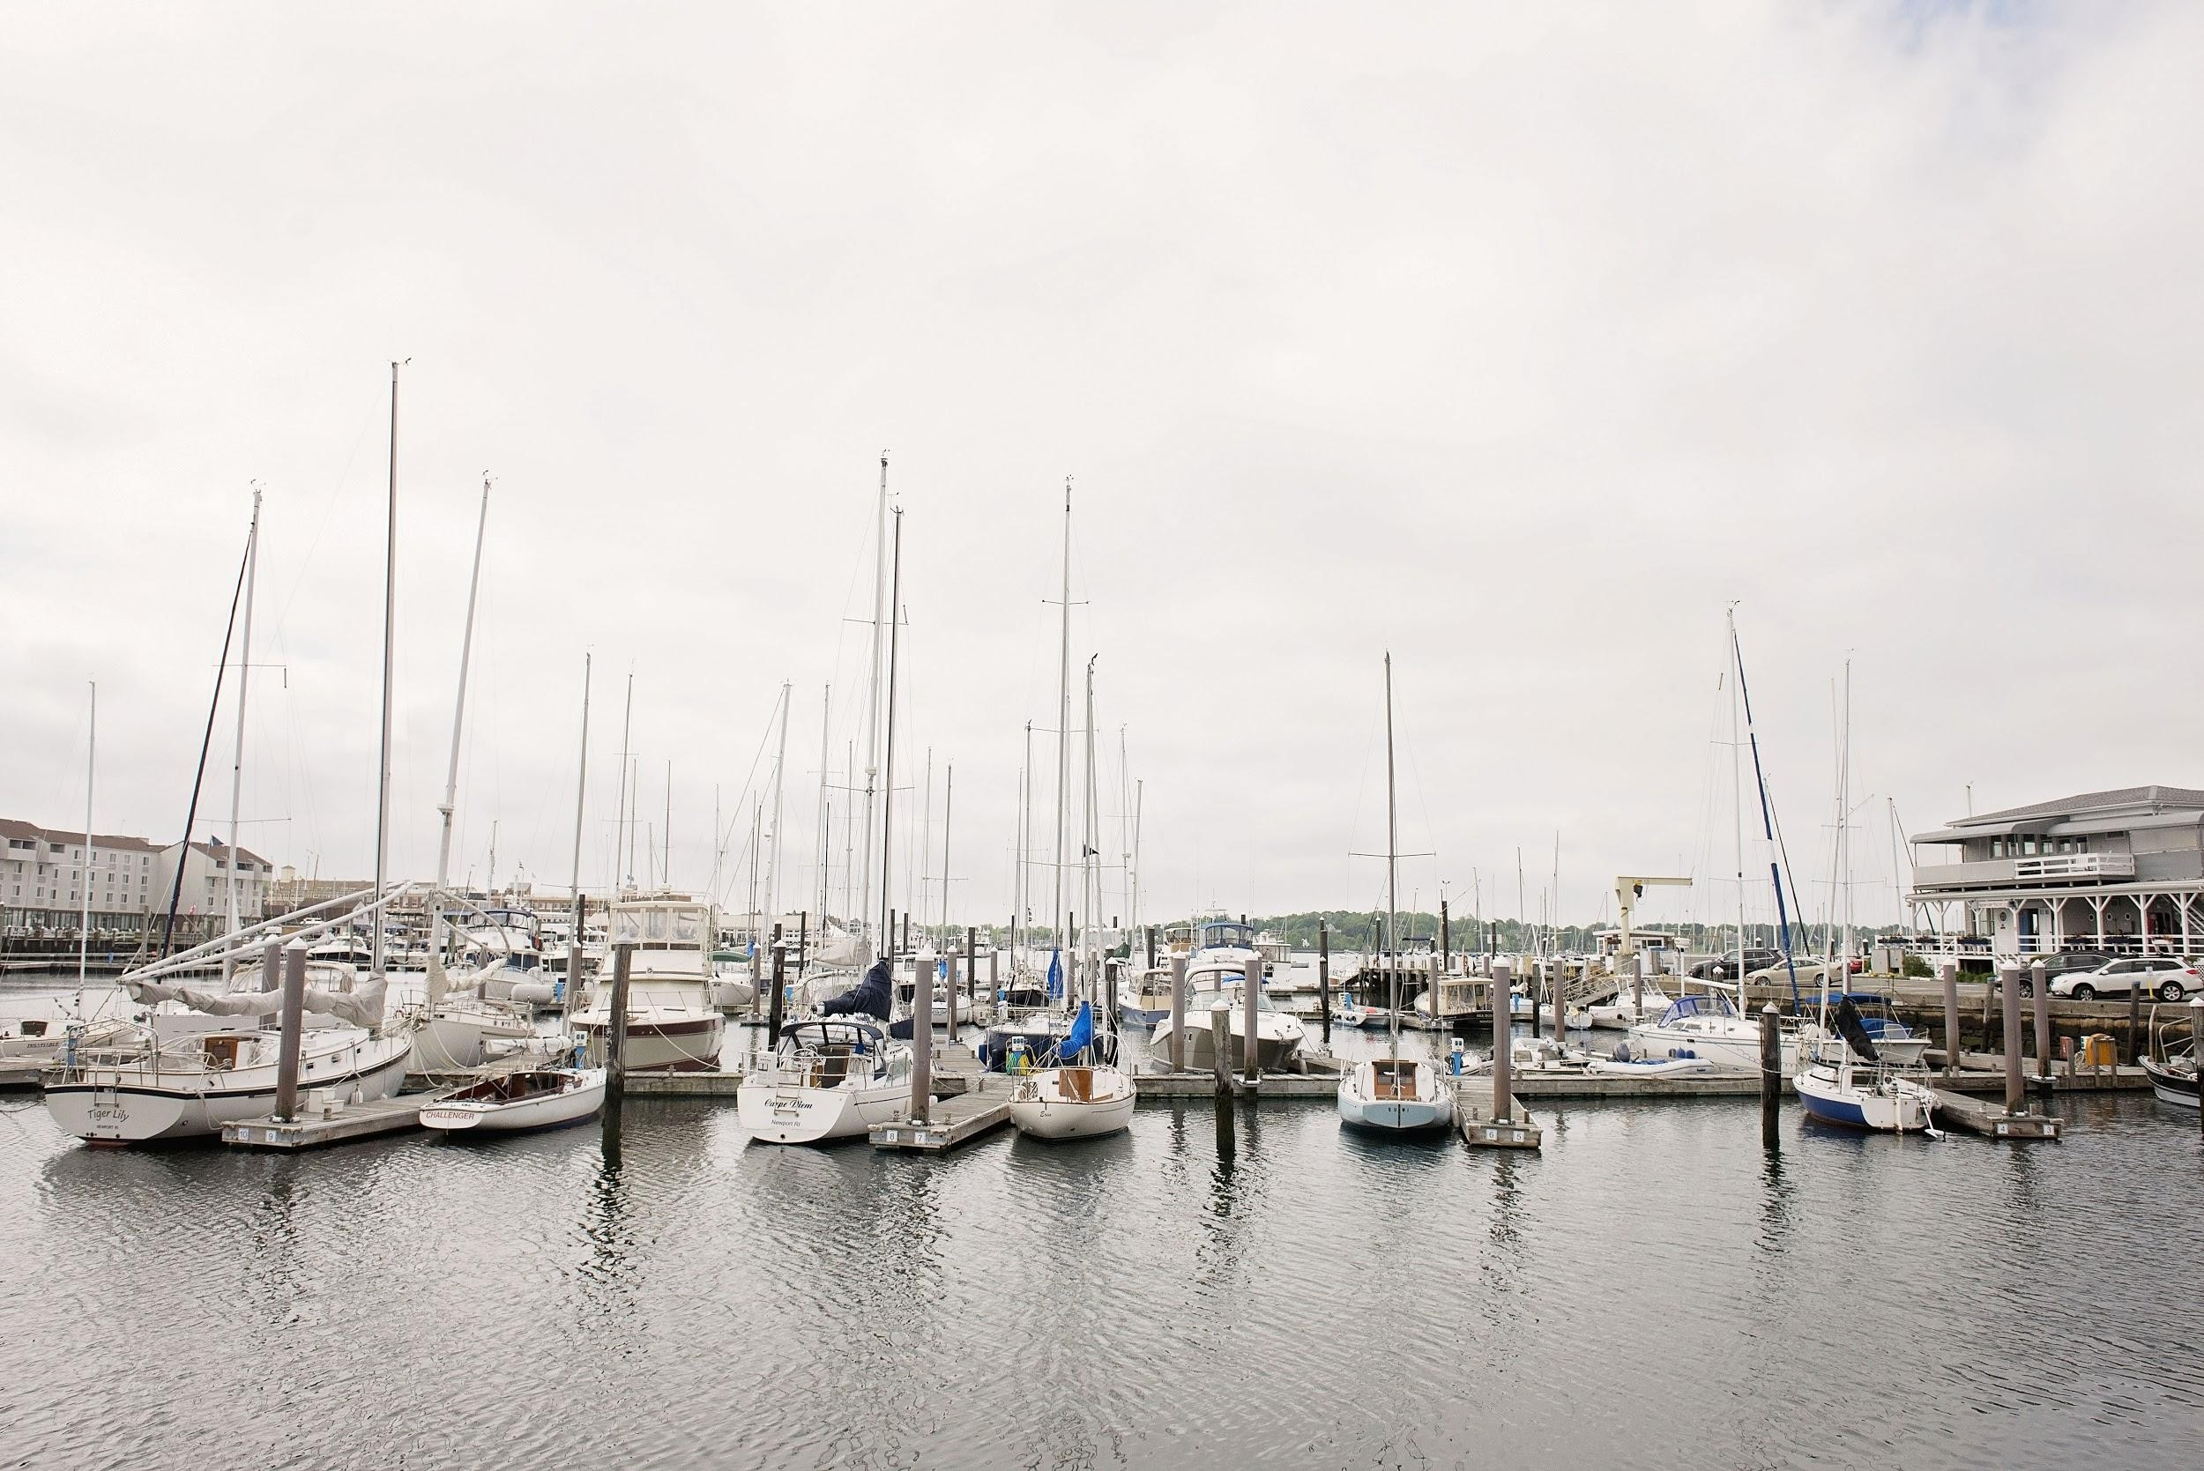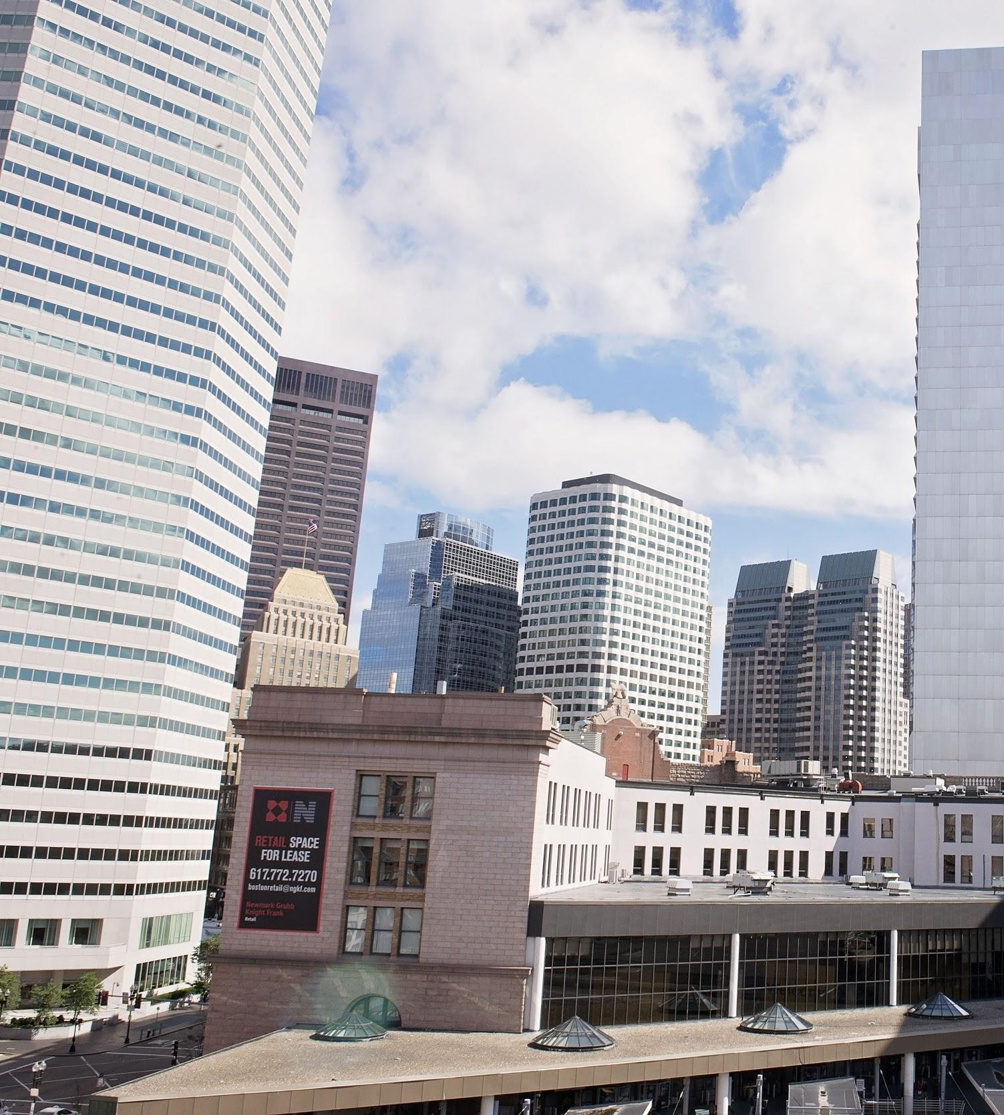

Recreation

 | Sunday June 25th | Monday June 26th | Tuesday June 27th | Wednesday June 28th | Thursday June 29th | Friday June 30th
7:00AM |  | Wake Up/Breakfast | Wake Up/Breakfast | Wake Up/Breakfast | Wake Up/Breakfast | Wake Up/Breakfast
8:00AM |  | Devos | Devos | Devos | Devos | Devos
9:00AM |  | @ Prospect Terrace | @ FBC of America | @ Federal Hill Park | @ India Point Park | Pack/Clean Up
10:00AM |  | Work Projects | Work Projects | Work Projects | Travel Time | Pray Over City
11:00AM |  | Work Projects | Work Projects | Work Projects | New Port | Hug Goodbye!
12:00PM |  | Lunch | Lunch | Lunch | New Port
1:00PM |  | Work Projects | Work Projects | Work Projects | Lunch
2:00PM |  | Food Distribution | Work Projects | Food | New Port
3:00PM |  | Food Distribution | Work Projects | Thrift Store | New Port
4:00PM |  | Showers | Work Projects | Thrift Store | New Port
5:00PM |  | Cook/Serve | Showers | Thrift Store | New Port
6:00PM | Check In | Dinner | Dinner | Dinner | Dinner
7:00PM | Team Meeting | Desserts/Clean Up | Taste Test Providence | Showers | Travel Time
8:00PM | Team Meeting | Team Meeting | Team Meeting | Team Meeting | Taste Test Providence
9:00PM | Settle In | Team Meeting | Team Meeting | Team Meeting | Debrief Meeting
10:00PM | Flex Time | Flex Time | Flex Time | Flex Time | Debrief Meeting
11:00PM | Lights Out | Lights Out | Lights Out | Lights Out | Lights Out

Sample Itinerary

